GRANARD MUNICIPAL DISTRICT

Corporate Affairs,
Aras an Chontae,
LONGFOIRT.

21st November 2017.

To: Each Member of Granard Municipal District.

Dear Member,

You are requested to attend Meeting of Granard Municipal District to be held in
Granard Community Library on Tuesday, 28th November 2017 at 3.30 p.m. to transact business, as set out on the Agenda hereunder.

Yours sincerely,
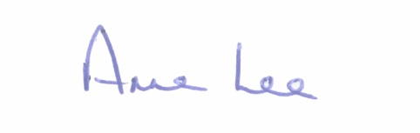

_______________
Anne Lee,
Meetings Administrator.

AGENDA

Prayer before meeting.

1. Confirmation of Minutes of the following meetings of Granard Municipal District -
- September Meeting held on the 26th September 2017.
- Committee Meeting held on the 24th October 2017.
- Special Meeting regarding 2018 General Municipal Allocation held on the 24th October 2017.
- copies enclosed.

2. Matters arising from Minutes.

4. Area Engineer’s Progress Report.

5. Notice of Motion submitted by Councillors, as listed hereunder –

Councillor Luie McEntire.

“What is the up-to-date position regarding the cleaning of rivers in the North Longford area, before the adjoining lands become flooded.”

Councillor Paraic Brady.

“I call on Longford County Council to put lights up on the Hill Road in Drumlish as there is a black spot between the Sliabh Cairbe Housing Estate, the School and Community Centre.”

“I call on Longford County Council to turn on the lights situated in Killoe Village beside Victor Kiernan’s Pub and the Veterinary Clinic as this is a village status and all is ready only to have them lit up.”

“I call on Longford County Council to put a notice in local papers and Shannonside Radio to notify all landowners that any dangerous trees must be removed from along the public roads and that the landowner is responsible for the same.”

Councillor Michael Carrigy.

“I call on Longford County Council to carry out a Low Cost Safety Scheme at L1925 Aughadowery, Ballinamuck.”`

“I call on Longford County Council to develop a new footpath in Aughnacliffe village to connect the existing path from the church/school with the housing estates.

Councillor P.J. Reilly.

“That Longford County Council to apply for a low cost scheme for the junction at Purth Cross to be staggered.”

“That more adequate signage to be erected at Esker Cross Killoe as you approach the junction.”

6. A.O.B.

